Another finding: the communication between board and display only works if both serial pins are connected. If one direction is missing, the other does not go either.

The picture shows the TFT pin assignment on the hub board, which is located in the printer base.

1 - + 5V (blue)

2 - nc

3 - RX (red, for TFT)

4 - TX (green, from TFT)

5 - GND (black)

**Uploaded files:**

* [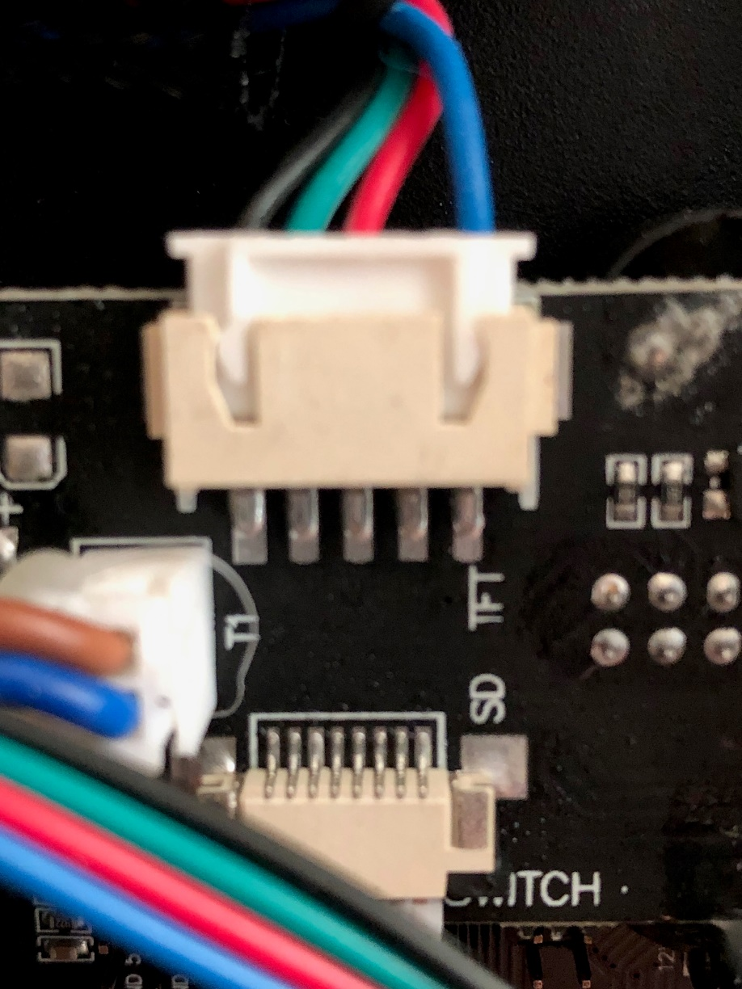](https://drucktipps3d.de/wp-content/uploads/asgarosforum/42702/BAFEA561-A908-4CEF-858D-FA405B4AE9C4.jpeg)

